**KDM LAB-2**

**N.AYYAPPA KUMAR 16157522.**

1. In order to develop the mobile web application I choose JSFiddle.net

2. My intention is to develop an application in such a manner which provides the direction from one place to another place by means of four different ways of transportation, they are driving, walking, bicycling, transit.

3. In order to develop this application, I used Google Map APIs as well as openweathermap.org API

4. In this application I created a Jquery ready function for id: "control".

So this control block initializes the map whenever it is loaded

$('#control').ready(function() {

initialize(41.850033, -87.6500523);

5. Here the user has to give the source and destination information in order to get the travelling directions between them, after that user has to click on submit button then route is calculated using calcRoute() function.

6. Then the direction between two places is displayed and the present weather conditions of those places are also be displayed.

JSFiddle link for the application: **http://jsfiddle.net/an5kc/zDgRP/10/**

Mobile Application view in JSFiddle.net

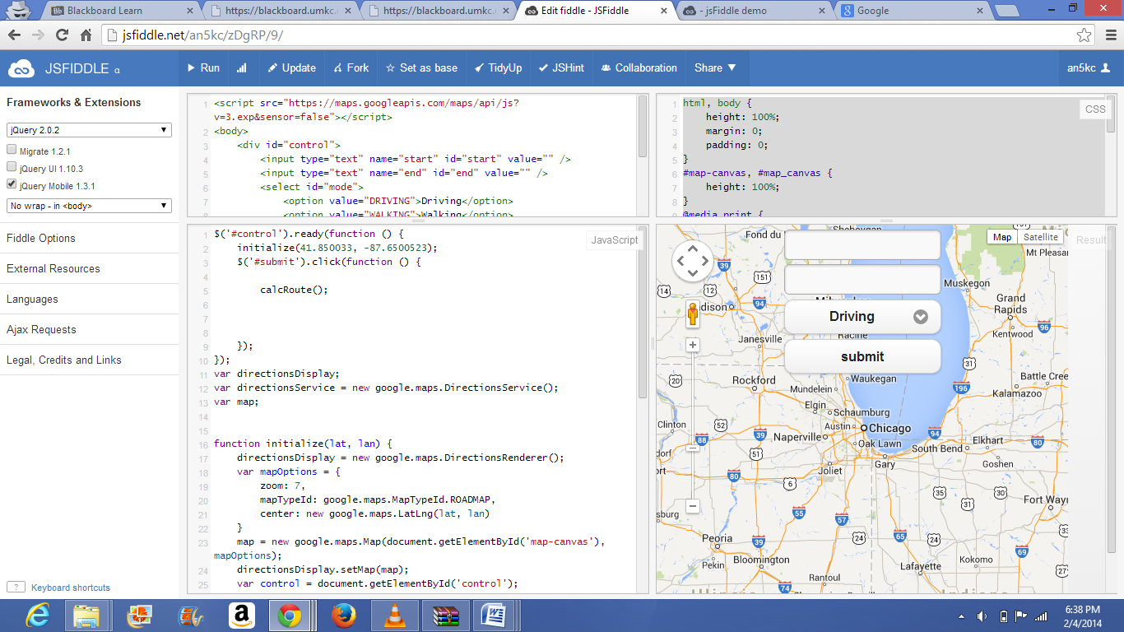

Here user want to get travelling directions from Kansas city to California and he choose mode of transportation as Driving. then the directions are displayed as of user requirement.

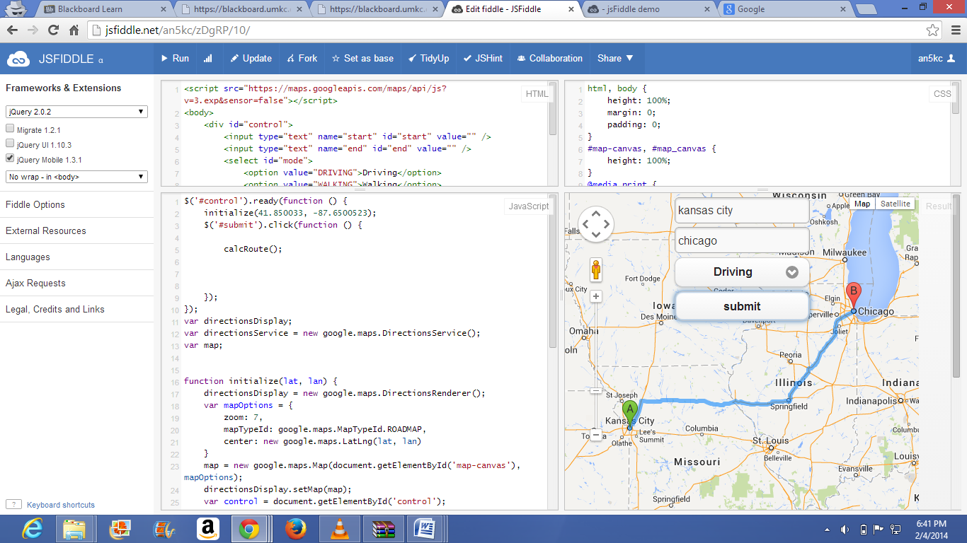

Here user want to get travelling directions from Kansas city to California and he choose mode of transportation as Walking. then the directions are displayed as of user requirement.

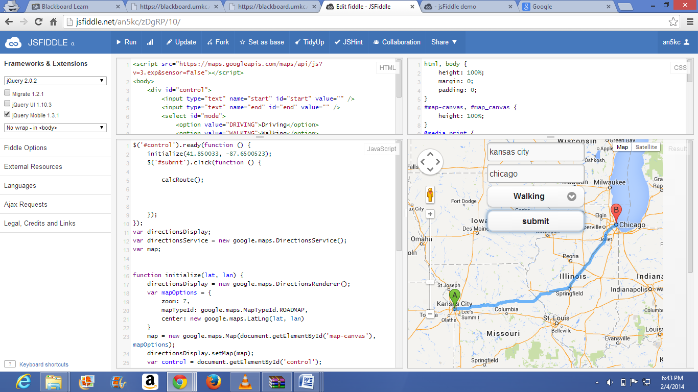

Here user want to get travelling directions from Kansas city to California and he choose mode of transportation as Bicycling. then the directions are displayed as of user requirement.

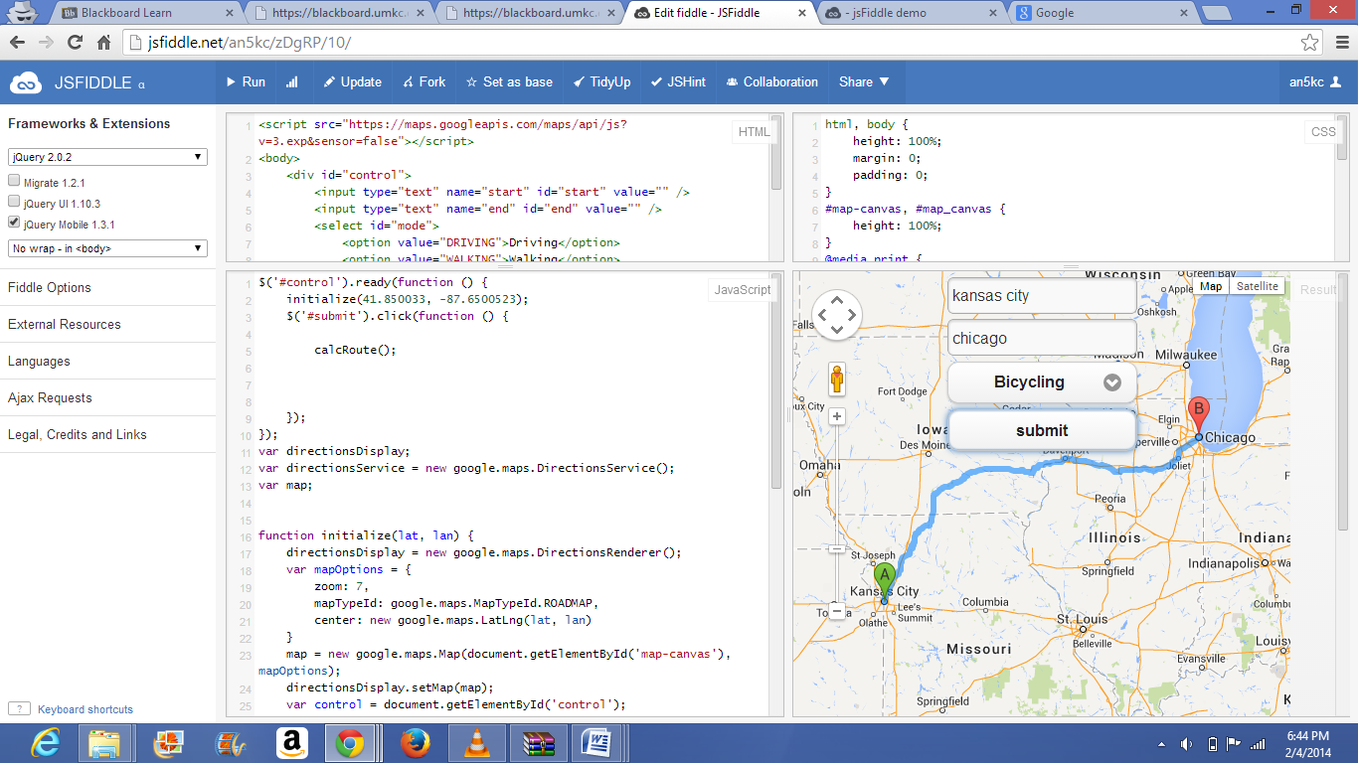

Here user want to get travelling directions from Kansas city to California and he choose mode of transportation as Transit. then the directions are displayed as of user requirement.

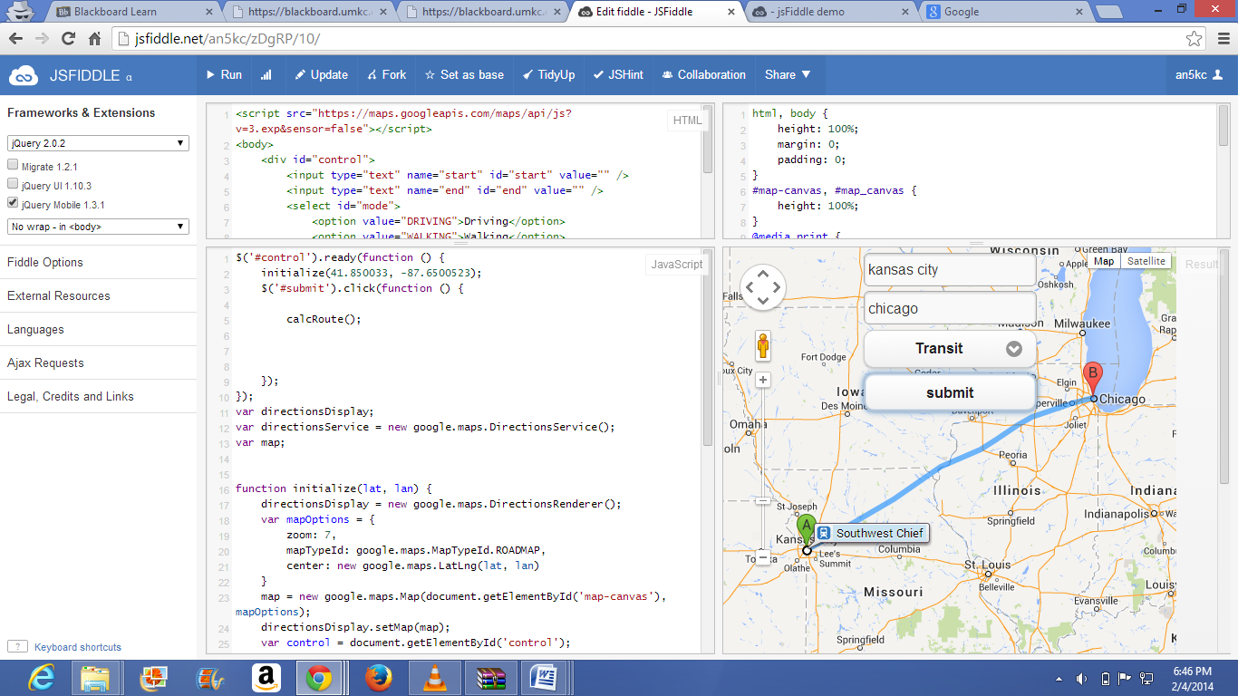

And in these all the cases it also shows what are the present weather conditions at those places.

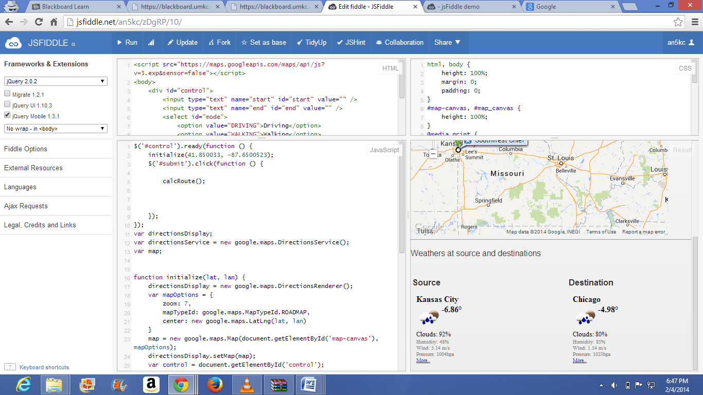

For mobile and desktop refer to link <http://jsfiddle.net/m/jgd/>

Application in mobile is displayed as below.

